15点21分 2022年2月19日星期六

Keywords:

produce ?-> adopt media -> publicity 宣传 scientist -> academic circle

unaccustomed->strange and unfamiliar rise-> ascend improved -> modified

not successful -> never be fully achieved

Sentences:

As the fuel passes through the tiny openings, it accumulates pressure. Once it makes its way through the openings, the pressure decreases and the liquid becomes gas so it can **bum up**.

当燃料通过微小的开口时，它积累了压力。一旦它通过开口，压力就会降低，液体就会变成气体，这样它就能**膨胀起来**。

The **debate** about the usefulness of academic research for business practices is a recent one.

关于学术研究对商业实践是否有用的**争论**是最近才出现的。

Why does AACSB put forward the recommendation?

Jonathan Aitken, a former cabinet minister, recounted(讲述了) a tale(故事) to illustrate the horrors he endured(忍受 承受) after a national newspaper tainted(玷污了) his name.

If writers have a compulsion(强迫性) to narrate(叙事), they compel(强迫) themselves to find insights about the human condition.

如果作家有叙事的强迫性，他们就会强迫自己去寻找关于人类状况的洞察力。

Given the universal compulsion to tell stories, art is the best way to refine and enjoy the particularly **outlandish** or insight till ones. 鉴于讲故事的普遍强迫性，艺术是提炼和享受特别**离奇**的或有洞察力的故事的最好方式。

They do not have the **impetus** to explain what they do not understand. 他们没有**动力**去解释他们不理解的东西。

Evidently, there is a **gushing** river of verbal creativity in the normal human mind, from which both artistic invention and lying. 显而易见，在正常人的头脑中，有一条**喷涌而出**的语言创造力的河流，艺术发明和谎言都来自于此。

lying and artistic storytelling **spring from**(发源于) a common **neurological root-**one that is **exposed** in the cases of **psychiatric patients** who suffer from a particular kind of **impairment(损伤)**. 撒谎和讲艺术故事源于一个共同的**神经学根源**--在患有某种特定**损伤**的**精神病人**的案例中，这个根源被**暴露**出来。

I'm fabulous at it 我在这方面很出色

The **fine line** between liars and artists 骗子和艺术家之间的**细微差别**

There is only one difference between cultured pearls and natural ones: in cultured pearls, the **irritant** is a head called ‘mother of pearl’ and is placed in the oyster through surgical implantation. 养殖珍珠和天然珍珠之间只有一个区别：在养殖珍珠中，**刺激物**是一个被称为 "珍珠母 "的头，通过手术植入牡蛎中。



得分 7 31/40

Question: Burning system produces double flame 燃烧系统产生双重火焰

Reading:

Both the 1996 and 2000 torches adopted a double flame burning system

1996年和2000年的火炬都采用了双火焰燃烧系统

There has been a tremendous deal of publicity on how severe desertification can be, but the academic circle has never agreed on the causes of desertification.

关于荒漠化会有多严重，已经有了大量的宣传，但学术界对荒漠化的原因从未达成一致。

The environment is **hostile** for any creature to inhabit. 那种环境对任何生物都是**不利的**。

|  |  |
| --- | --- |
| **Q38:** pressurize(加压) fuel rises from the improved ________ | As the fuel ascends through the modified handle, it is squeezed through a brass valve that has thousands of little openings. |

|  |  |
| --- | --- |
| **Q36:** __________ coated by aluminum base | The torch at the 1996 Atlanta Summer Olympics is equipped with an aluminium base that accommodates a tiny fuel tank. |

错解 tank 正确答案 tiny fuel tank 要求***NO MORE THAN THREE WORDS*** , 那就多写几个词。

|  |  |
| --- | --- |
| **Q22:** The media is uninterested in the problems of desertification | There has been a tremendous deal of publicity on how severe desertification can be, but the academic circle has never agreed on the causes of desertification. |

给段落定标题

|  |  |
| --- | --- |
| **Q20:** a description of the adverse effects of growing food crops | Since the population has become denser, the cultivation of crops has gone into progressively drier areas. It’s especially possible for these regions to go through periods of severe drought, which explains why crop failures are common. The raising of most crops requires the natural vegetation cover to be removed first; when crop failures occur, extensive tracts of land are devoid of a plant cover and thus susceptible to wind and water erosion. |

|  |  |
| --- | --- |
| **Q15:** mention of a **productive land** turning into a desert in the 20th century  提到在20世纪，一片**富饶的土地**变成了一片沙漠 | (G) In the 20th century, one of the states of America had a large section of farmland(耕地) that had turned into desert. |

|  |  |
| --- | --- |
| **Keywords in Questions** | **Similar words in Passage** |
| **Q9:** was not successful in proving a theory | A young physician Jean Marc Gaspard Itard was optimistic about the future of Victor and initiated a five-year education plan to civilise him and teach him to speak. With a subsidy from the government, Itard recruited a local woman Madame Guerin to assist him to provide a semblance of a home for Victor, and he spent an enormous amount of time and effort working with Victor. Itard’s goal to teach Victor the basics of speech could never be fully achieved, but Victor had learnt some elementary forms of communication. |

In the UK, every five years, the Research Assessment Exercise (RAE) inspects research institutions to determine their rate of **27**  This tends to cause **28** . in academic institutions because any failure would lead to **29** - financial consequences. RAE’s purpose, however, is to increase the academic output within research institutions. In response to the **30**  of RAE, the research institutions are changing the way they do things. Some are forcing their research staff to **31**  almost anything.

In the year ahead, the UK government is due to carry out the next Research Assessment Exercise (RAE ). The goal of this regular five-yearly check-up of the university sector is easy to understand: to increase productivity within public sector research. But striving for such productivity can lead to unfortunate consequences. In the case of the RAE, one risk attached to this is the creation of an overly controlling management culture that threatens the future of imaginative science.

Academic institutions are already preparing for the RAE with some anxiety—understandably so, for the financial consequences of failure are severe. Departments with a current rating of four or five (research is rated on a five point scale, with five the highest) must maintain their score or face a considerable loss of funding. Meanwhile, those with ratings of two or three are fighting for their survival.

The pressures are forcing research management onto the defensive. Common strategies for increasing academic output include grading individual researchers every year according to RAE criteria, pressurising them to publish anything regardless of quality, diverting funds from key and expensive laboratory science into areas of study such as management, and even threatening to close departments. Another strategy being readily adopted is to remove scientists who appear to be less active in research and replace them with new, probably younger, staff.

Although such measures may deliver results in the RAE , they are putting unsustainable pressure on academic staff. Particularly insidious is the pressure to publish. Put simply, RAE committees in the laboratory sciences must produce four excellent peer-reviewed publications per member of staff to meet the assessment criteria. Hence this is becoming a minimum requirement for existing members of staff, and a benchmark against which to measure new recruits.

|  |  |
| --- | --- |
| **Keywords in Questions** | **Similar words in Passage** |
| **Q27:** In the UK, every five years, the Research Assessment Exercise (RAE) inspects research institutions to determine their rate of ……….  在英国,每五年一次的研究评估活动(RAE)对研究机构进行检查，以确定其生产率的比率 | The goal of this regular five-yearly check-up of the university sector is easy to understand: to increase productivity within public sector research.  对大学部门进行这种五年一次的定期检查的目的很容易理解: 提高公共部门研究的生产率。 |
| **Note:**  From the question, we can assume that the answer must be **a noun.** The keywords in this question are “**Research Assessment Exercise (RAE)**” and “**research institutions**”. After skimming, we can locate the relevant information in the second paragraph. It is mentioned that “*the goal of this regular five-yearly check-up of the university sector is to increase productivity*”. We should notice “**regular five yearly**” is similar to “**every five year**”; “**check-up**” is equivalent to “**inspect**”. Therefore, **the answer for Q27 is productivity.** | |

|  |  |
| --- | --- |
| **Keywords in Questions** | **Similar words in Passage** |
| **Q28:** This tends to cause ………. in academic institutions | Academic institutions are already preparing for the RAE with some anxiety |
| **Note:**  From the question, we can assume that the answer must be **a noun.** The keyword concerned in this question is “**academic institutions**”. As mentioned, “*academic institutions are already preparing for the RAE with some anxiety*”, we can conclude that **the answer for Q28 is anxiety.** | |

|  |  |
| --- | --- |
| **Keywords in Questions** | **Similar words in Passage** |
| **Q29:** because any failure would lead to ………. financial consequences | Academic institutions are already preparing for the RAE with some anxiety—understandably so, for the financial consequences of failure are severe. |
| **Note:**  From the question, we can assume that the answer could be **an adjective.** It is mentioned that “*the financial consequences of failure are severe*”. We should notice “**for**” and “**because**” are interchangeable in this case. Therefore, **the answer for Q29 is severe.** | |

|  |  |
| --- | --- |
| **Keywords in Questions** | **Similar words in Passage** |
| **Q30:** In response to the ………. of RAE, the research institutions are changing the way they do things. | The pressures are forcing research management onto the defensive. |
| **Note:**  From the question, we can assume that the answer must be **a noun.** The keywords concerned in this question are “**research institutions**” and “**changing”**. As mentioned, “*the pressures are forcing research management onto the defensive*”, we can conclude that **the answer for Q30 is pressures.** | |

错误原因: 关键词是主语research institutions 而不是 RAE

|  |  |
| --- | --- |
| **Keywords in Questions** | **Similar words in Passage** |
| **Q31:** Some are forcing their research staff to ………. almost anything, | Common strategies for increasing academic output include grading individual researchers every year according to RAE criteria, pressurizing them to publish anything regardless of quality, |
| **Note:**  From the question, we can assume that the answer must be **a verb.** It is mentioned that *common strategies include pressurizing researchers to publish anything***.** We should notice **“researchers”** are similar to **“research staff”; “pressurize”** is equivalent to **“force’.** Therefore, **the answer for Q31 is publish.** | |

Answer YES NO or NOT GIVEN

|  |  |
| --- | --- |
| **Keywords in Questions** | **Similar words in Passage** |
| **Q24:** It can take a decade to develop a single geothermal power station. | To achieve this, extensive surveys, drilling expertise and time are needed. It is not uncommon for a project to encompass ten years from its planning stage to the start of operations. |
| **Note:**  The keywords concerned in this question are “**a decade**”, “**develop”** and “**geothermal power station”**. It is mentioned in paragraph G that “*it is not uncommon for a project to encompass ten years from its planning stage to the start of operations*”. We should notice “**ten years**” and “**a decade**” are interchangeable. This information agrees with the given statement, therefore, **the answer for Q24 is YES.** | |

|  |  |
| --- | --- |
| **Keywords in Questions** | **Similar words in Passage** |
| **Q20:** Accessing geothermal energy at depths greater than 3 km is currently not possible. | In certain areas, where the earth's surface has been altered over time—through, for example, volcanic activity-temperatures exceeding 300 degrees Celsius can be found at depths of a mere 1 to 3 km, which can be feasibly accessed.  在某些地区，地球表面随着时间的推移被改变，例如，通过火山活动，可以在仅仅1至3公里的深度发现超过300摄氏度的温度，这是很可行的。 |
| **Note:**  It is mentioned in paragraph B that *volcanic activity-temperatures exceeding 300 degrees Celsius can be found at depths of a mere 1 to 3 km, which can be feasibly accessed*. We should notice “**feasible**” is similar to “**possible**”. This information disagrees with the given statement, therefore, **the answer for Q20 is NO.**  B段中提到，在仅有1至3公里的深度可以发现超过300摄氏度的火山活动-温度，可以可行地进入。我们应该注意到 "可行的 "与 "可能的 "相似。这一信息与给定的陈述不一致，因此，问题20的答案是否定的。 | |

此题为匹配段落

|  |  |
| --- | --- |
| **Keywords in Questions** | **Similar words in Passage** |
| **Q19:** problems of geothermal exploration | A further consideration is the amount of risk involved in successfully setting up a new geothermal power production facility. |
| **Note:**  The keywords concerned in this question are “**problems**” and “**geothermal exploration**”. It is mentioned in paragraph G that “*a further consideration is the amount of risk involved in successfully setting up a new geothermal power production facility*”. We should notice “**risk**” can be inferred as “**problem**” in this case; “**setting up a new geothermal power production facility**” is paraphrased as “**geothermal exploration**”. Therefore, **the answer for Q19 is G.** | |

**G**

A further consideration is the amount of risk involved in successfully setting up a new geothermal power production facility. The drill-ing that must extend 2,000 to 3,000 m below the surface must be accurate to within a matter of just a few metres one side or the other of the targeted location. To achieve this, extensive surveys, drilling expertise and time are needed. It is not uncommon for a project to encompass ten years from its planning stage to the start of operations. The extent of the risks involved is clear.

|  |  |
| --- | --- |
| **Keywords in Questions** | **Similar words in Passage** |
| **Q13:** The Snowy Mountains Scheme was considered an ………. which altered Australian society thereafter. | As well as being a great engineering feat, the scheme is a monument to people from around the world who dared to change their lives. |
| **Note:**  From the question, we can assume that the answer must be **a noun.** It is mentioned in the end of the passage that “*as well as being a great engineering feat, the scheme is a monument to people from around the world who dared to change their lives*”. We should notice “**change**” and “**alter**” are interchangeable. Therefore, **the answer for Q13 is engineering feat(工程壮举).** | |

|  |  |
| --- | --- |
| **Keywords in Questions** | **Similar words in Passage** |
| **Q10:** Year  Tumut III Power Station completed | To do this, thousands of kilometres of tunnels had to be drilled through the mountains, and sixteen major dams and seven hydro-electric power stations built over a period of nineteen years. The first of these was Guthega Power Station, which was commissioned in 1954, and the last one to be finished was Tumut III. |
| **Note:**  The keyword concerned in this question is **Tumut III Power Station.** After skimming, we can locate the relevant information in the end of section one. It is mentioned that “*seven power stations built over a period of nineteen years. The first was commissioned in 1954, and the last one to be finished was Tumut III*”. We should notice “**commission**” and “**finish**” are equivalent to “**complete**”; nineteen years after 1954 is 1973. Therefore, **the answer for Q10 is 1973.** | |

|  |  |
| --- | --- |
| **Keywords in Questions** | **Similar words in Passage** |
| **Q9:** Snowy Mountains Scheme begins Recruitment of ………. people from abroad | It sought labour from overseas, and 60,000 of the 100,000 people who worked on the scheme came from outside the country. |
| **Note:**  From the question, we can assume that the answer could be **a number**. It is mentioned in the beginning of section two that “*60,000 of the 100,000 people who worked on the scheme came from outside the country*”. We should notice “**from outside the country**” is similar to “**from abroad**”. Therefore, **the answer for Q9 is 60,000.** | |

|  |  |
| --- | --- |
| **Keywords in Questions** | **Similar words in Passage** |
| **Q3:** Section Three | Many new arrivals spoke only limited English, and were offered English classes after work. The men needed primarily to understand safety instructions, and safety lectures were conducted in English and other languages. In fact, a great deal of communication underground was by sign language, especially when the conditions were noisy. |
| **Note:**  It is mentioned in section three that “*many new arrivals were offered English classes after work*”; “*a great deal of communication underground was by sign language*”. We should notice “**sign language**” and **English** are new ways to communicate. Therefore, **the answer for Q3 is heading viii.** | |

|  |  |
| --- | --- |
| **Keywords in Questions** | **Similar words in Passage** |
| **Q3:** Section Three | Many new arrivals spoke only limited English, and were offered English classes after work. The men needed primarily to understand safety instructions, and safety lectures were conducted in English and other languages. In fact, a great deal of communication underground was by sign language, especially when the conditions were noisy. |
| **Note:**  It is mentioned in section three that “*many new arrivals were offered English classes after work*”; “*a great deal of communication underground was by sign language*”. We should notice “**sign language**” and **English** are new ways to communicate. Therefore, **the answer for Q3 is heading viii.** | |

[IELTS Recent Mock Tests Volume 5 Reading Practice Test 2 (ieltsonlinetests.com)](https://ieltsonlinetests.com/22344464/result/ielts-recent-mock-tests-volume-5-reading-practice-test-2)

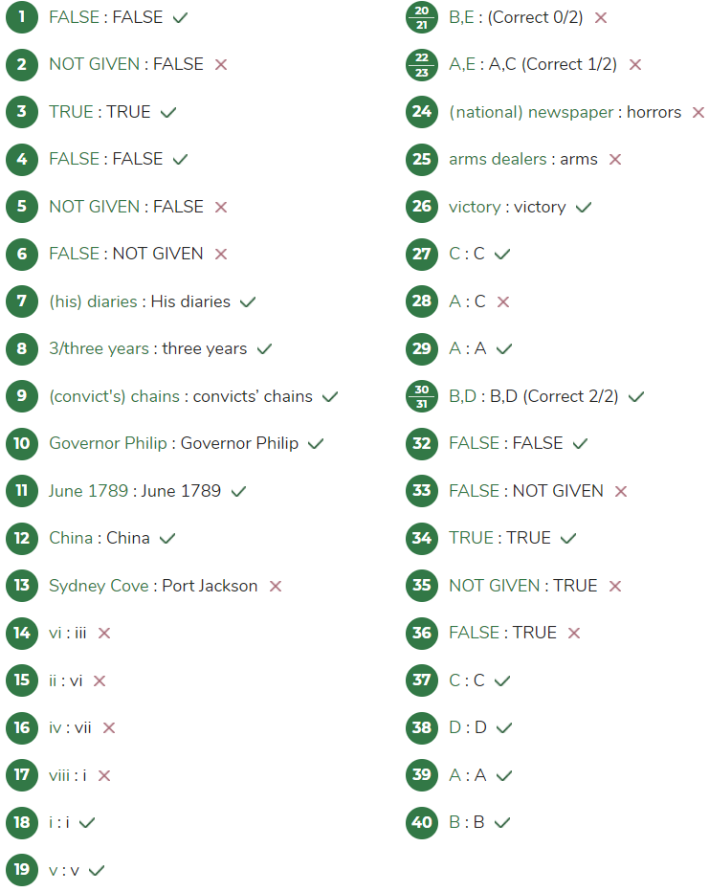

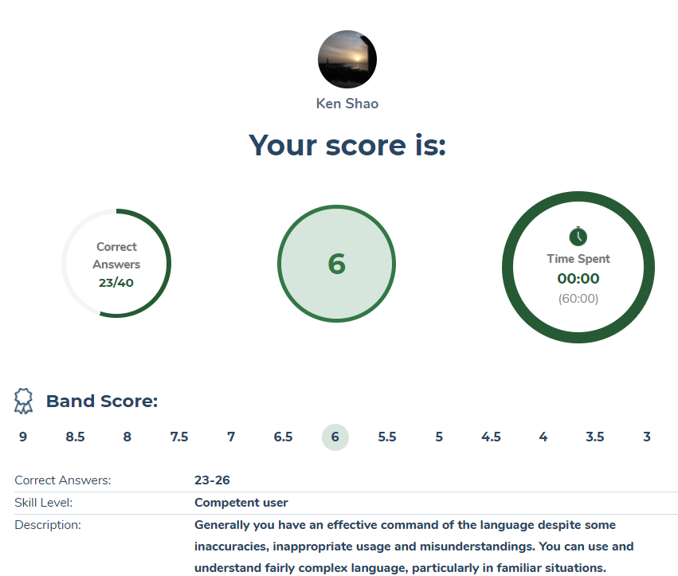

33 35 36

判断对错

|  |  |
| --- | --- |
| Keywords in Questions | Similar words in Passage |
| Q33: AACSB’s draft report was not reviewed externally. | The most controversial recommendation in AACSB’s draft report (which was sent round to administrators for their comment) |
| Note:  Question: AACSB’s draft report was not reviewed externally.  Passage: which was sent round to administrators for their comment.  For that reason, the answer is FALSE | |

|  |  |
| --- | --- |
| Keywords in Questions | Similar words in Passage |
| Q35: Many universities pursue professional outputs. | If a school chose to specialize in professional outputs rather than academic outputs, it could use such a large sum of money and redirect it into more fruitful programs. |
| Note:  The passage mentions professional outputs, but there is nothing such how many universities choose it.  For that reason, the answer is NOT GIVEN | |

|  |  |
| --- | --- |
| Keywords in Questions | Similar words in Passage |
| Q36: Greater publications benefit professors and students as well. | Greater publications will attract greater funding, which will in turn be spent on better publications. |
| Note:  Question: benefit professors and students  Passage: attract great funding  For that reason, the answer is FALSE | |

Why does AACSB put forward the recommendation?

A **24**  accused(指控) Jonathan Aitken, a former cabinet minister, who was selling and buying with **25** .

错解: arms. 正解: arm dealers

因为 buying with + people 对象是人，而非物。

|  |  |
| --- | --- |
| Keywords in Questions | Similar words in Passage |
| Q24: A _________ accused Jonathan Aitken, a former cabinet minister, | During a now-famous libel case in 1996. Jonathan Aitken, a former cabinet minister, recounted a tale to illustrate the horrors he endured after a national newspaper tainted his name. |
| Note:  Here we must find a noun or a noun phrase, after scanning the keywords, “national newspaper” is the answer.  So, the answer is national newspaper | |

|  |  |
| --- | --- |
| Keywords in Questions | Similar words in Passage |
| Q22-23:  Which TWO of the following statements about playwrights and novelists are true?   1. They give more meaning to the stories. 2. They tell lies for the benefit of themselves. 3. They have nothing to do with the truth out there. 4. We can be misled by them if not careful. 5. We know there are lies in the content. | * Playwrights and novelists are not literally attempting to deceive us because the rules are **laid out**(制定) in advance: come to the theatre, or open this book, and we'll lie to you. * If writers have a compulsion to narrate, they compel themselves to find insights about the human condition. |
| Note:  Considering every detail in the question and in the passage, we can see that A and E is the correct answers.  For that reason, the answers are A and E (in any orders) | |

|  |  |
| --- | --- |
| Keywords in Questions | Similar words in Passage |
| Q28:  Why does AACSB put forward the recommendation?   1. to give full play to the faculties’ **advantage**. 2. to give full play to the faculties’ advantage. 3. to push professors to publish competitive papers. 4. to reduce costs of research in universities. | AACSB justifies its stance by saying that it wants schools and faculty to play to their **strengths**, whether they be in pedagogy, in the research of practical applications, or in scholarly endeavor. |
| Note:  Considering every detail in the paragraph, we can find that A is the most suitable choice.  For that reason, the answer is  A | |

|  |  |
| --- | --- |
| Keywords in Questions | Similar words in Passage |
| Q17: Creativity when people lie | Evidently there is a gushing river of verbal creativity in the normal human  mind, from which both artistic invention and lying are drawn. |
| Note:  After skimming, we see that paragraph D mentions the creativity of people from artistic mind and lying mind.  For that reason, the answer is viii | |

|  |  |
| --- | --- |
| Keywords in Questions | Similar words in Passage |
| Q16: Confabulations and the exemplifiers | In the language of psychiatry, this woman was “confabulating”. Chronic confabulation is a rare type of memory problem that affects a small proportion of brain damaged people. |
| Note:  Paragraph C mentions the problems about chronic confabulation and takes some patients as examples.  For that reason, the answer is iv | |

A case study published in 1985 by Antonio Damasio, a neurologist, tells the story of a middle-aged woman with brain damage caused by a series of strokes. She retained cognitive abilities, including coherent speech, but what she actually said was rather unpredictable. Checking her knowledge of contemporary events, Damasio asked her about the Falklands War. In the language of psychiatry, this woman was “confabulating”. Chronic confabulation is a rare type of memory problem that affects a small proportion of brain damaged people. In the literature it is defined as "the production of fabricated, distorted or misinterpreted memories about oneself or the world, without the conscious intention to deceive”. Whereas amnesiacs make errors of omission, there are gaps in their recollections they find impossible to fill - confabulators make errors of commission: they make tilings up. Rather than forgetting, they are inventing. Confabulating patients are nearly always oblivious to their own condition, and will earnestly give absurdly implausible explanations of why they're in hospital, or talking to a doctor. One patient, asked about his surgical sear, explained that during the Second World War he surprised a teenage girl who shot him three times in the head, killing him, only for surgery to bring him back to life. The same patient, when asked about his family, described how at various times they had died in his arms, or had been killed before his eyes. Others tell yet more fantastical tales, about trips to the moon, fighting alongside Alexander in India or seeing Jesus on the Cross. Confabulators aren’t out to deceive. They engage in what Morris Moseovitch, a neuropsychologist, calls “honest lying". Uncertain and obscurely distressed by their uncertainty, they are seized by a “compulsion to narrate": a deep-seated need to shape, order and explain what they do not understand. Chronic confabulators are often highly inventive at the verbal level, jamming together words in nonsensical but suggestive ways: one patient, when asked what happened to Queen Marie Antoinette of France, answered that she had been “suicided" by her family. In a sense, these patients are like novelists, as described by Henry James: people on whom "nothing is wasted". Unlike writers, however, they have little or no control over their own material.

|  |  |
| --- | --- |
| *From Q14-Q19: Matching headings to paragraphs*   * *Underline the keywords in the headings* * *Skim each paragraph to get the topic and the main idea* * *Compare the list of headings with your topic sentence and topic words to see the connection. Get the answer.*   *Remember that one paragraph only has one heading* | |
| Keywords in Questions | Similar words in Passage |
| Q14: The fine line between liars and artists | "If you can lie. you can act." Brando told Jod Kaftan, a writer for Rolling Slone and one of the few people to have viewed the footage. “Are you good at lying?” asked Kaftan. "Jesus." said Brando. “I'm fabulous at it". |
| Note:  The paragraph A mentions the connection between liars and artists “If you can lie, you can act”.  For that reason, the answer is vi | |

Shortly before his death, Marlon Brando was working on a series of instructional videos about acting, to he called "Lying for a Iiving”. On the surviving footage, Brando can he seen dispensing gnomic advice on his craft to a group of enthusiastic, if somewhat bemused, Hollywood stars, including Leonardo Di Caprio and Sean Penn. Brando also recruited random people from the Los Angeles street and persuaded them to improvise (the footage is said to include a memorable scene featuring two dwarves and a giant Samoan). "If you can lie, you can act." Brando told Jod Kaftan, a writer for Rolling Stone and one of the few people to have viewed the footage. “Are you good at lying?” asked Kaftan. "Jesus." said Brando, “I'm fabulous at it".

**B**

|  |  |
| --- | --- |
| Keywords in Questions | Similar words in Passage |
| Q13: In which place did Tench feel unaccustomed? | A few days after arrival at Botany Bay, their original location, the fleet moved to the more suitable Port Jackson where a settlement was established at Sydney Cove(悉尼湾) on 26 January 1788. This second location(此处使用就近原则，第二指的就是Sydney Cove) was strange and unfamiliar, and the fleet was on alert for any kind of suspicious behaviors. |

|  |  |
| --- | --- |
| Keywords in Questions | Similar words in Passage |
| Q5: An Aboriginal gave him gifts of food at the first time they met. | He recalled the first time he stepped into this  unfamiliar ground with a boy who helped Tench navigate. In these new lands, he met an old Aboriginal. |
| Note:  Passage mentions an old Aboriginal, but there is no such thing like “gave him gifts of food”  For that reason, the answer is NOT GIVEN | |

|  |  |
| --- | --- |
| Keywords in Questions | Similar words in Passage |
| Q2: Tench drew pictures to illustrate different places during the voyage. | During the voyage, which was harsh and took many months, Tench described landscape of different places. |
| Note:  原文说用日记记录，但是没有明确提出画画是错误的，并不代表没有画画。(我原错填了False)  The passage mentions that he described landscape of different places, but there is no such thing as “drew pictures”.  So, the answer is NOT GIVEN | |

[IELTS Recent Mock Tests Volume 6 Reading Practice Test 5 (ieltsonlinetests.com)](https://ieltsonlinetests.com/22391216/result/ielts-recent-mock-tests-volume-6-reading-practice-test-5) 17点45分 2022年2月25日

 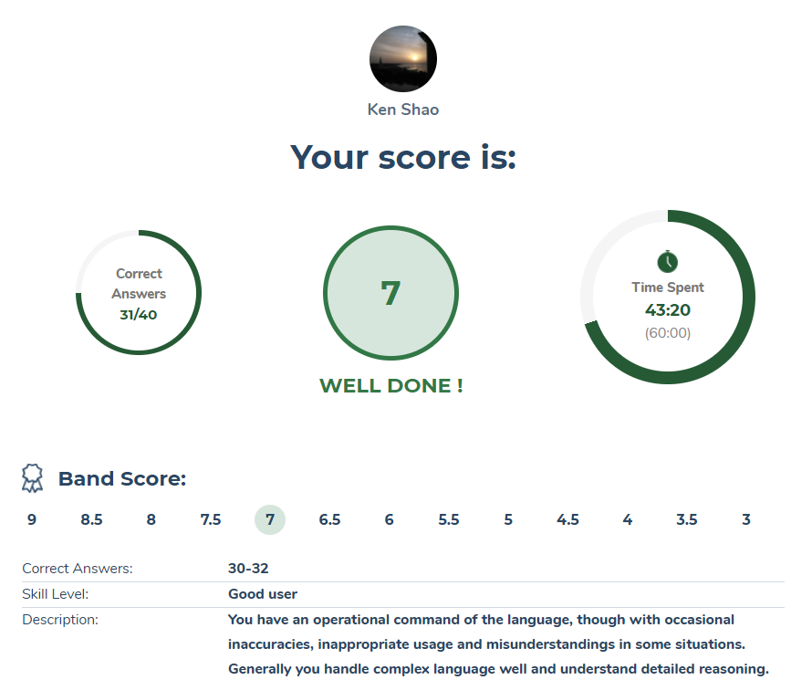

错之题：4,5,6,12,16,17,20, 27, 32, //33,34,35,36,37,38,39 第一次

4,6,16,20,27,32,35,36,38 第二次

段落匹配标题

|  |  |
| --- | --- |
| **Keywords in Questions** | **Similar words in Passage** |
| **Q4:** a growth mechanism(生长机制) that distinguishes cultured pearls from natural ones | **C** A cultured pearl undergoes the same process. There is only one difference between cultured pearls and natural ones: in cultured pearls, the irritant is a head called ‘mother of pearl’ and is placed in the oyster through surgical implantation. |
| **Note**:  The keywords for Q4 are “growth mechanism”, “distinguish cultured from natural pearls”.  **After reading passage 1,** we can easily see only paragraph C mention that “There is only one difference between cultured pearls and natural ones: in cultured pearls, the irritant is a head called ‘mother of pearl’ and is placed in the oyster through surgical implantation”. It means that “the mother of pearl in oyster through surgical implantation” is used to distinguish cultured pearls and natural ones.  Thus, **the correct answer** for **Q4** should be **“C”** | |

此题错因: 需要在原文中搜索的关键词是distinguishes cultured pearls from natural ones, 而非 growth mechanism

|  |  |
| --- | --- |
| **Keywords in Questions** | **Similar words in Passage** |
| **Q6:** Also, pearls were even used as a medicine for people in… | In the eastern countries like **Persia,** ground pearl powders could be used as a medicine to cure anything including heart diseases and epilepsy. |
| **Note**:  The keywords for Q6 are “medicine for people”  We can assume the answer for Q6 may be a specific place (country, city…)  **After reading paragraph A,** we easily can see all keywords are mentioned.  We can read that “ground pearl powders could be used as a medicine to cure… in eastern countries like Persia”, it means that “pearls were used as a medicine for people in Persia.  Thus, **the correct answer** for **Q6** should be **“Persia”** | |

错因: 忽略了in 可+ 地名

|  |  |
| --- | --- |
| **Keywords in Questions** | **Similar words in Passage** |
| **Q16**  improved the utilisation rate of automobile space | BMC first launched a revolutionary space-friendly Mini in 1959, which turned out to harvest large global sales. Previously remaining under the Austin and Morris names, Mini later became an individual marque in 1969. |
| **Note**:  The keywords for Q16 are “utilisation”, “automobile space”  **After reading paragraph 6,** we can read “BMC first launched a revolutionary space-friendly Mini in 1959”  “Revolutionary space-friendly” and “utilization rate of automobile space” refer to the same meaning in this case.  Thus, **the correct answer** for **Q16** should be **“B”** | |

错因: 忽略了关键词 space, 很多时候形容词性的生词(utilization),并不一定是关键词，不认识也不用纠结，而是要找被其修饰的名词 space.

|  |  |
| --- | --- |
| **Keywords in Questions** | **Similar words in Passage** |
| **Q20**  What is the important feature owned by the modem engine since the 19th century? | In 1806, the first batch of cars powered by an internal combustion engine came into being, which pioneered the introduction of the widespread modem **petrol-fueled internal combustion engine** in 1885. |
| **Note**:  The keywords for Q20 are “important feature”, “modem engine”, “19th century”  **After reading paragraph 1,** we can read “pioneered the introduction of the widespread modem **petrol-fueled internal combustion engine** in 1885”, it means that the important feature of modem since 19th century is petrol-fueled internal combustion.  Thus, **the correct answer** for **Q20** should be **“petrol-fueled internal combustion”** | |

|  |  |
| --- | --- |
| **Keywords in Questions** | **Similar words in Passage** |
| **Q27**  What is the main idea of the passage?  **A** The influence of the cars on the environment  **B** The historical development and innovation in car designs  **C** The beginning of the modem designed gasoline engines  **D** The history of human and the Auto industry |  |
| **Note**:  The keywords for Q27 are “main idea of passage”  **After reading passage 2,** we can rule out option A, C and D as correct answers for Q27 because:   * Option A and option C is only contains information in paragraph 9 or paragraph 1, it did not mention the history and development of car and any car brands that following above paragraphs. * Passage 2 did not mention any information relating the history of human. Therefore, option D is not correct.   Thus, **the correct answer** for **Q27** should be **“B”** | |

The start of the automobile’s history went all the way back to 1769 when automobiles running on the steam engine were invented as carriers for human transport. In 1806, the first batch of cars powered by an internal combustion engine came into being, which pioneered the introduction of the widespread modem petrol-fueled internal combustion engine in 1885.

It is generally acknowledged that the first practical automobiles equipped with petrol/gaso-line-powered internal combustion engines were invented almost at the same time by different German inventors who were Working on their own. Karl Benz first built the automobile in 1885 in Mannheim. Benz attained a patent for his invention on 29 January 1886, and in 1888, he started to produce automobiles in a company that later became the renowned Mercedes-Benz.

以后问文章主旨，优先读前两段

等一下从第32题接着读

|  |  |
| --- | --- |
| **Keywords in Questions** | **Similar words in Passage** |
| **Q32**  How the elephants sense these sound vibrations is still unknown, but O’Connell-Rodwell, a postdoctoral researcher at Stanford University, proposes that elephants are ‘listening’ with their …. | It remains unclear how the elephants detect such vibrations, but O’ Connell-Rodwell raises a point that the pachyderms(长臂动物) are ‘listening’ with their trunks and feet instead of their ears. |
| **Note**:  We can assume that the answer for Q32 may a noun  **After reading paragraph 4,** we can see some synonyms in Q32 and in the context.  “unknown” and “unclear” refer to the same meaning in this case.  In addition, “O’ Connell-Rodwell raises a point that the pachyderms are ‘listening’ with their trunks and feet instead of their ears”, it means that “O’Connell-Rodwell proposes that elephants are listening with their trunks and feet.  “Thus, **the correct answer** for **Q32** should be **“trunks and feet”** | |

错因：看走眼了instead of而不是, …A instead of B, 肯定A 更重要

|  |  |
| --- | --- |
| **Keywords in Questions** | **Similar words in Passage** |
| **Q33**  … by two kinds of nerve endings that respond to vibrations with both … frequency and slightly higher frequencies | Both trunk and feet contain two types of nerve endings that are sensitive to pressure – one detects **infrasonic** vibration, and another responds to vibrations higher in frequencies. |
| **Note**:  We can assume that the answer for Q33 may an adjective.  **After reading paragraph 4,** we can easily read that “both trunk and feet contain two types of nerve endings, one detects infrasonic vibration, and one respond to vibrations higher in frequencies”. It means that two kinds of nerve ending respond to vibrations with both infrasonic and higher frequencies.  “Thus, **the correct answer** for **Q33** should be **“infrasonic”** | |

|  |  |
| --- | --- |
| **Keywords in Questions** | **Similar words in Passage** |
| **Q35**  but O’Connell-Rodwell was the first person to indicate that a large land animal would send and receive **…** too | Nevertheless, O’Connell-Rodwell first argued that a giant land animal is also sending and receiving **seismic signals** |
| **Note**:  We can assume that the answer for Q34 may a noun.  **After reading paragraph 5,** we can easily some synonyms between Q35 and information in context.  “first person indicate” and “first argue” refer to the same meaning in this case.  “large” and “giant” are interchangeable in this case.  So, through paragraph 5, “large land animal would send and receive seismic signals”  Thus, **the correct answer** for **Q35** should be **“seismic signals”** | |

|  |  |
| --- | --- |
| **Keywords in Questions** | **Similar words in Passage** |
| **Q36**  Also, he noticed the freezing behaviour by putting a male planthopper on a stem and play back a female call, which might prove the existence of other communicative approaches besides… | I find it so fascinating, and it got me thinking that perhaps **auditory communication** is not the only thing that is going on.’ |
| **Note**:  We can assume that the answer for Q36 may a noun.  **After reading paragraph 5,** we can read “perhaps auditory communication is not the only thing that is going on”, it means that besides auditory communication might have the existence of other communicative approaches”  Thus, **the correct answer** for **Q36** should be **“auditory communication”** | |

|  |  |
| --- | --- |
| **Keywords in Questions** | **Similar words in Passage** |
| **Q38**  Finally, the results of our 2002 study showed us that elephants could detect warning calls through the  **…** | ‘The outcomes of our 2002 study revealed that elephants could indeed sense warning signals through the ground |
| **Note**:  We can assume that the answer for Q38 may a noun  **After reading paragraph 7,** we can read “The outcomes of our 2002 study revealed that elephants could indeed sense warning signals through the ground”, it means that “the results of 2002 study showed that elephants could detect warning signals through the ground”  “outcomes” and “results” are interchangeable in this case.  “warning signals” and “warning calls” refer to the same meaning in this context.  Thus, **the correct answer** for **Q38** should be **“ground”** | |

错因: 原文中有两个2002, 而我之看到了第一个就填了 “电子设备” 然而关键词是 warning calls , 在第二个才出现。

We now know that elephants can respond to warning calls in the air, but can they detect signals transmitted solely through the ground? To look into that matter, the research team designed an experiment in 2002, which used electronic devices that enabled them to give out signals through the ground at Mushara. ‘The outcomes of our 2002 study revealed that elephants could indeed sense warning signals through the ground,’ O’Connell-Rodwell observes.